**CFC Project submission guidelines**

**Step1:**

Open <https://callforcode.org/challenge/> and

click on ***Accept the Challenge***

**Step 2:**

Form team of upto max 5 members

**Step 3**:

Join the ***Call for Code Slack Community*** using below link

<https://callforcode.org/faq/>

**Step 4:**

(a) Once after completion of your project. Submit your project by opening this url <https://callforcode.org/submit/> and click on ***Submit your solution as the team lead***

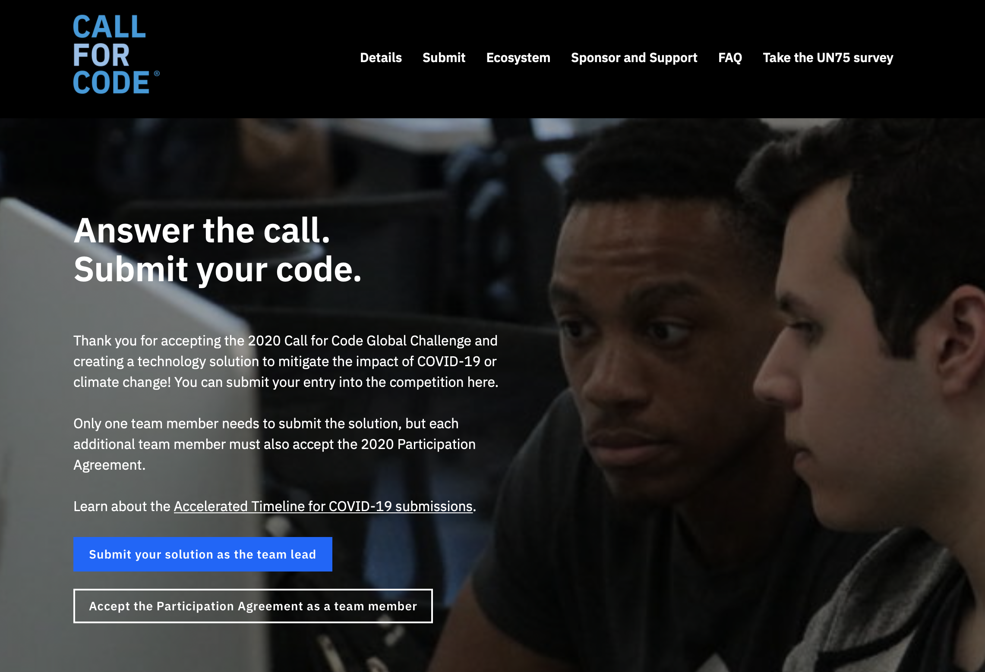

(b) Click on ***Start now***



(c) Click on ***I accept***

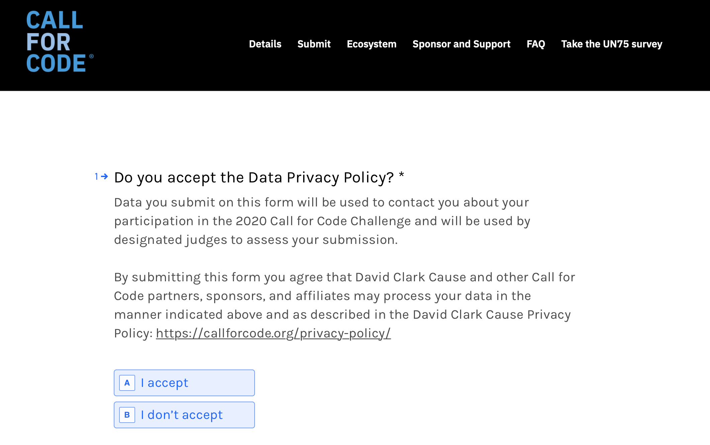

(d) Click on ***I accept***

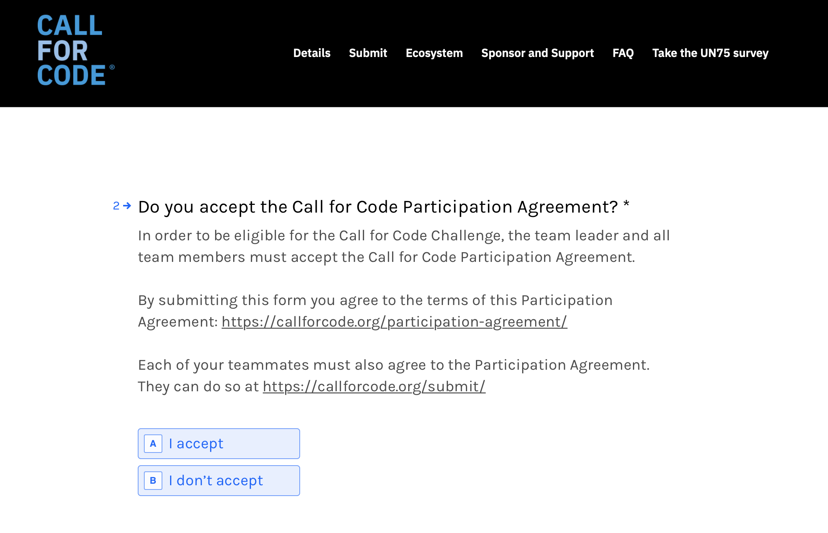

(e) Click on ***I accept***

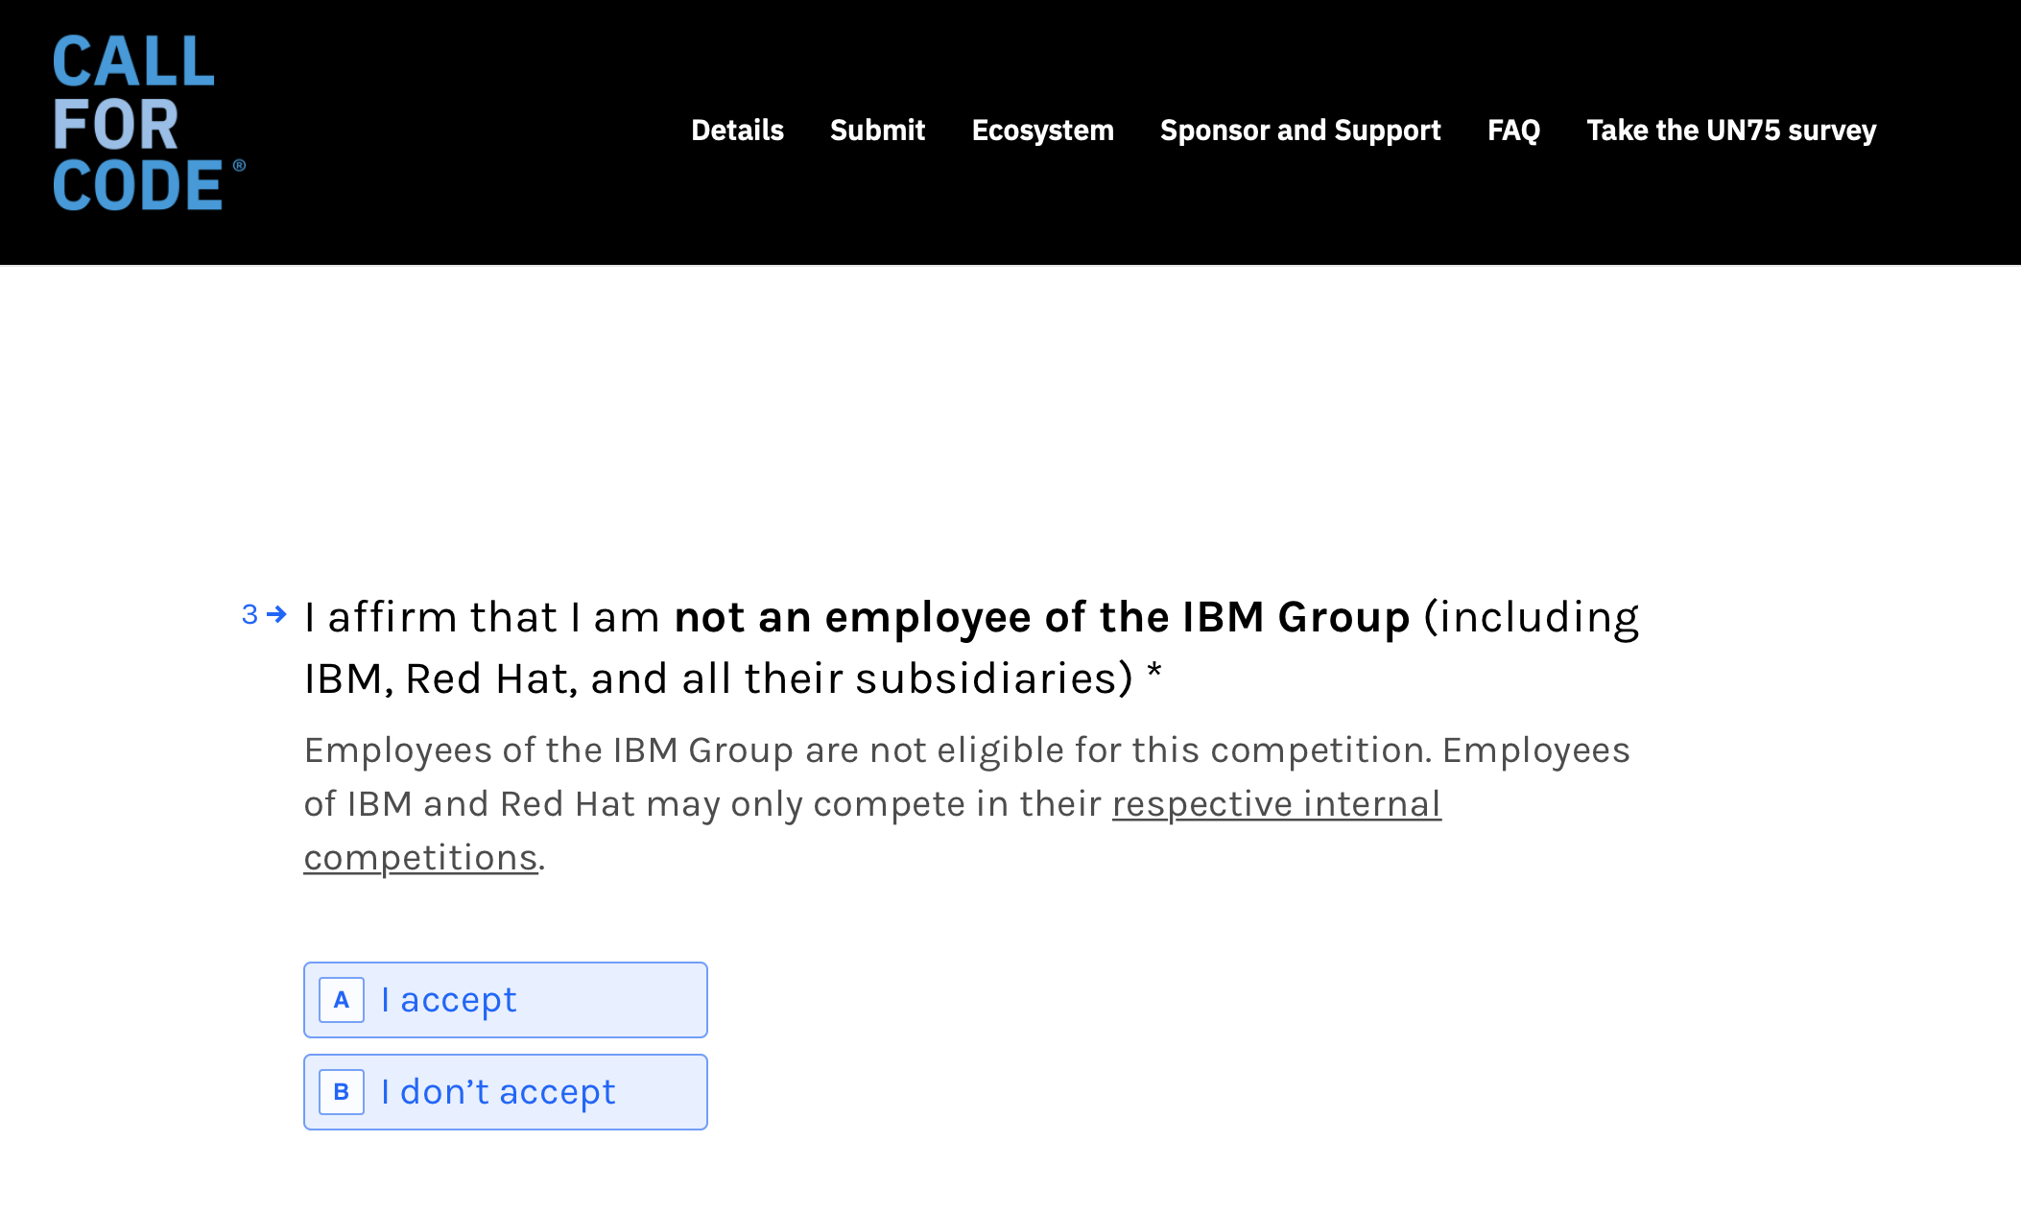

(f) Give team name or project name

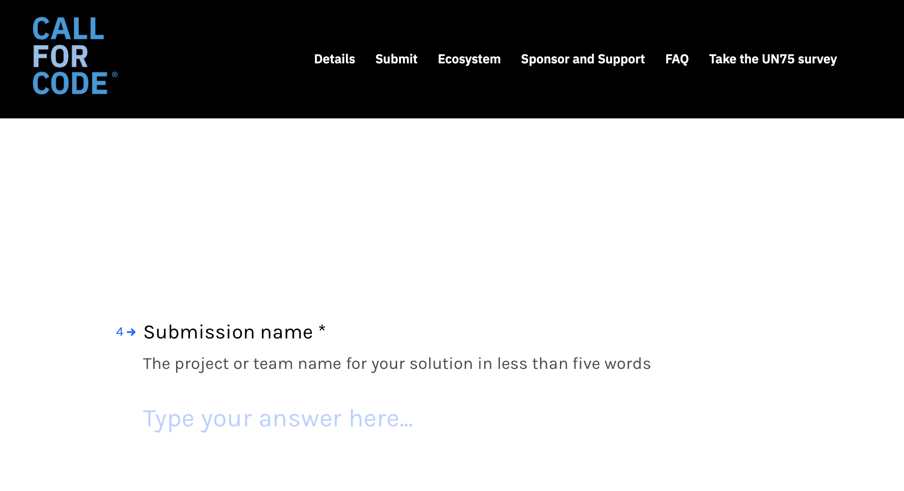

(g) After giving team name or project name click on ***ok***

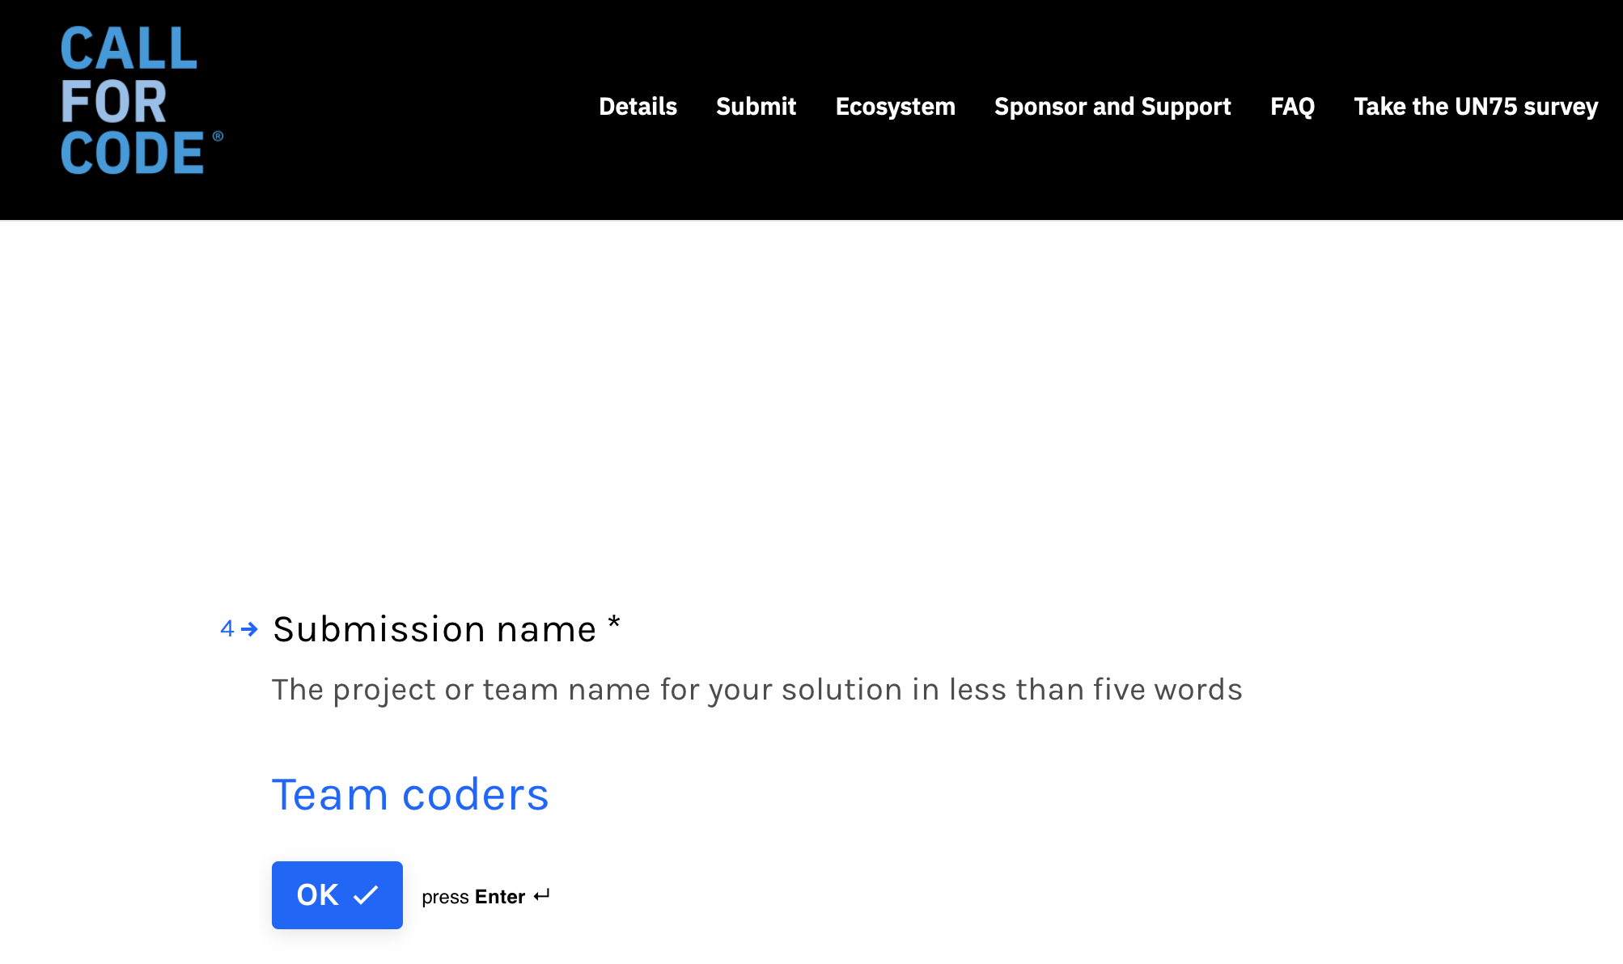

(h) Give short description about your project

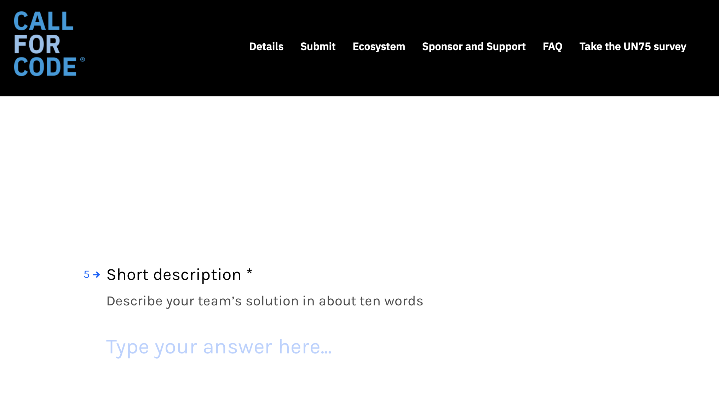

(i)After giving some description click on ***ok***

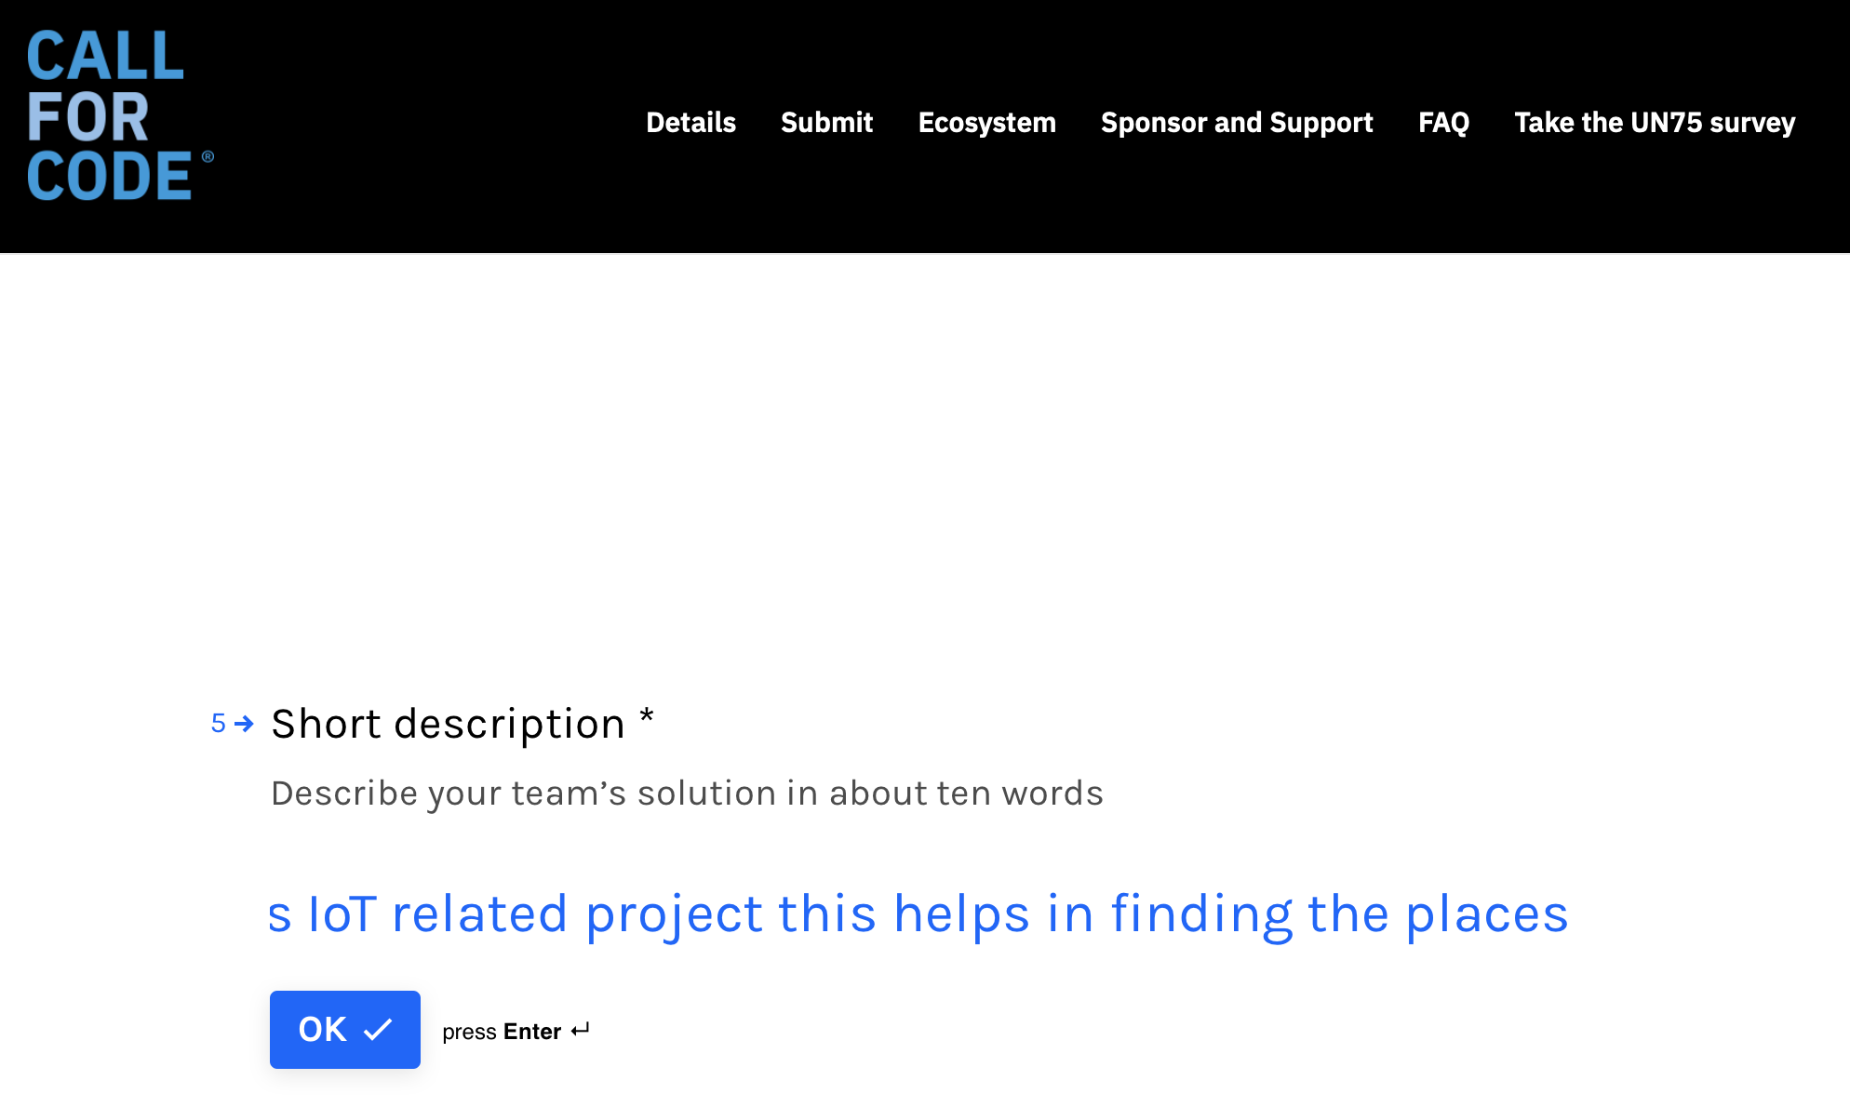

(j)Choose your submission track

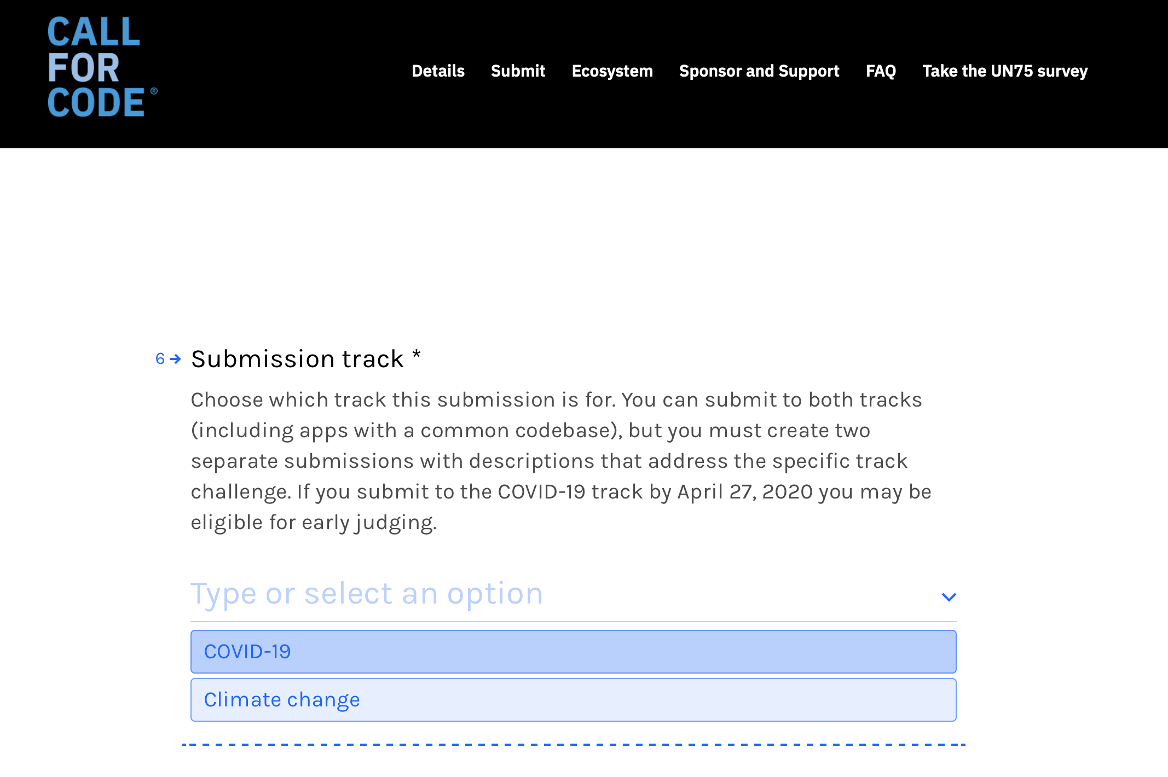

(k) Give your github url where your project is there

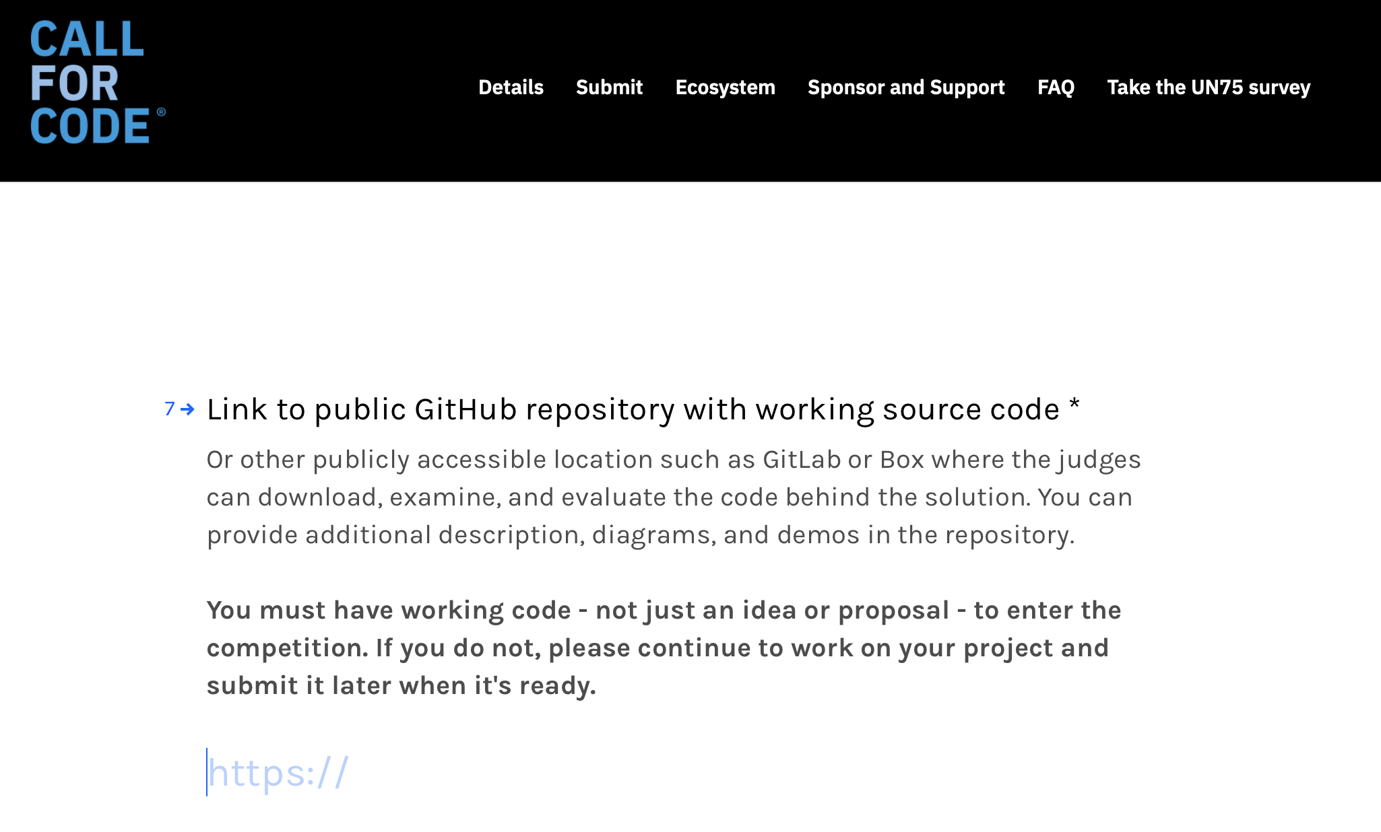

(l) Then click on ***ok***

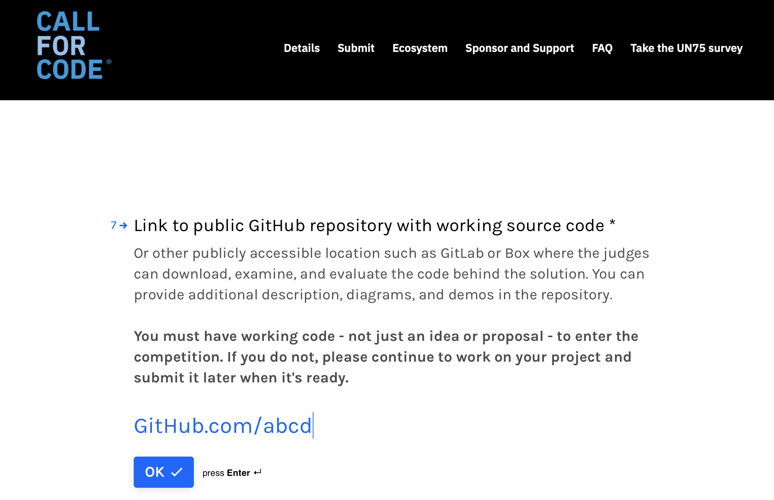

(m) Give a video link about your project demo

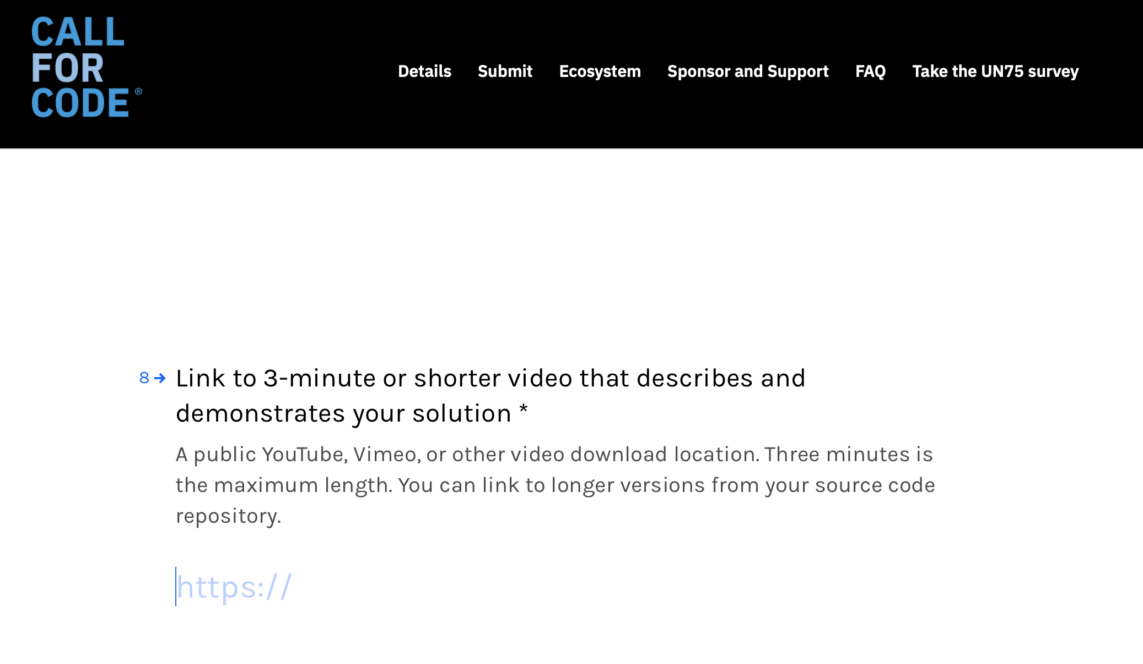

(n) Then click on ***ok***

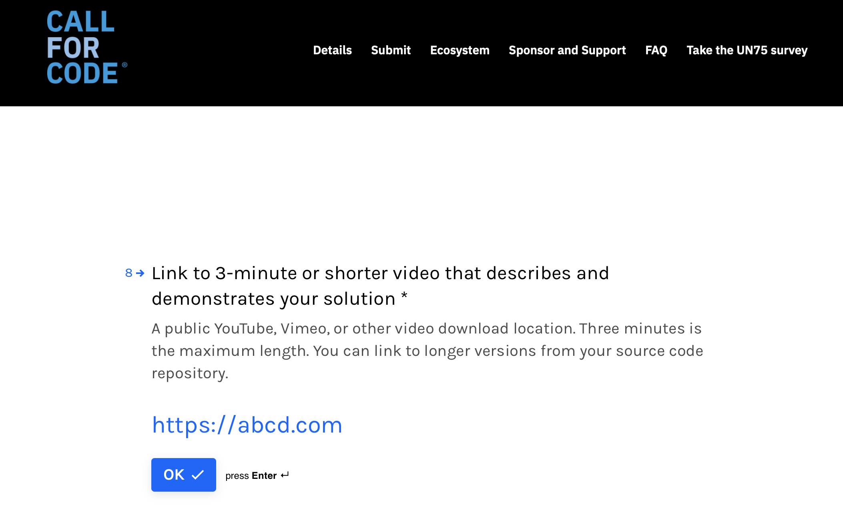

(o) Give long description about your project

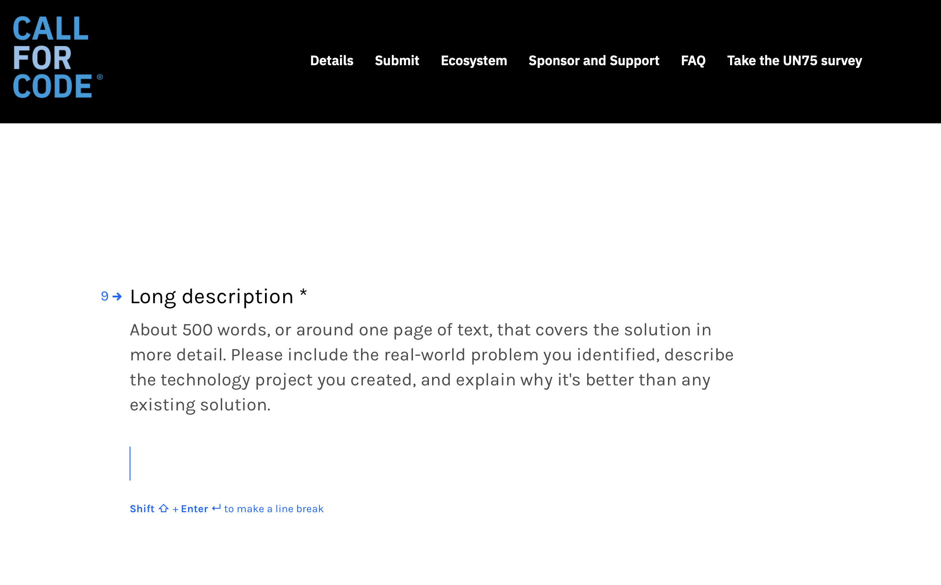

(p) After giving long description click on ***ok***

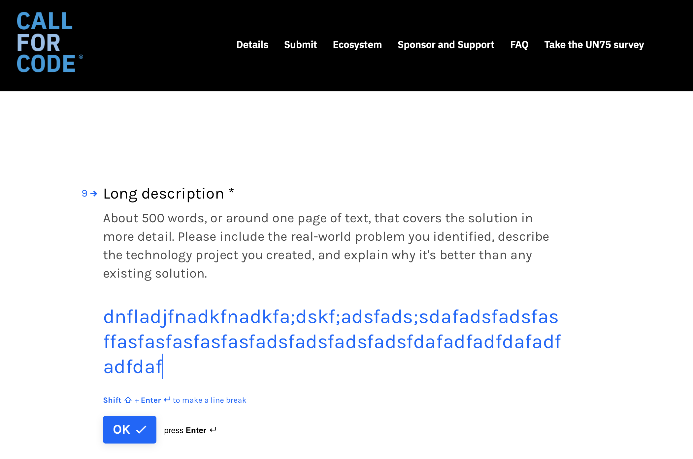

(q) Give your used IBM services or system

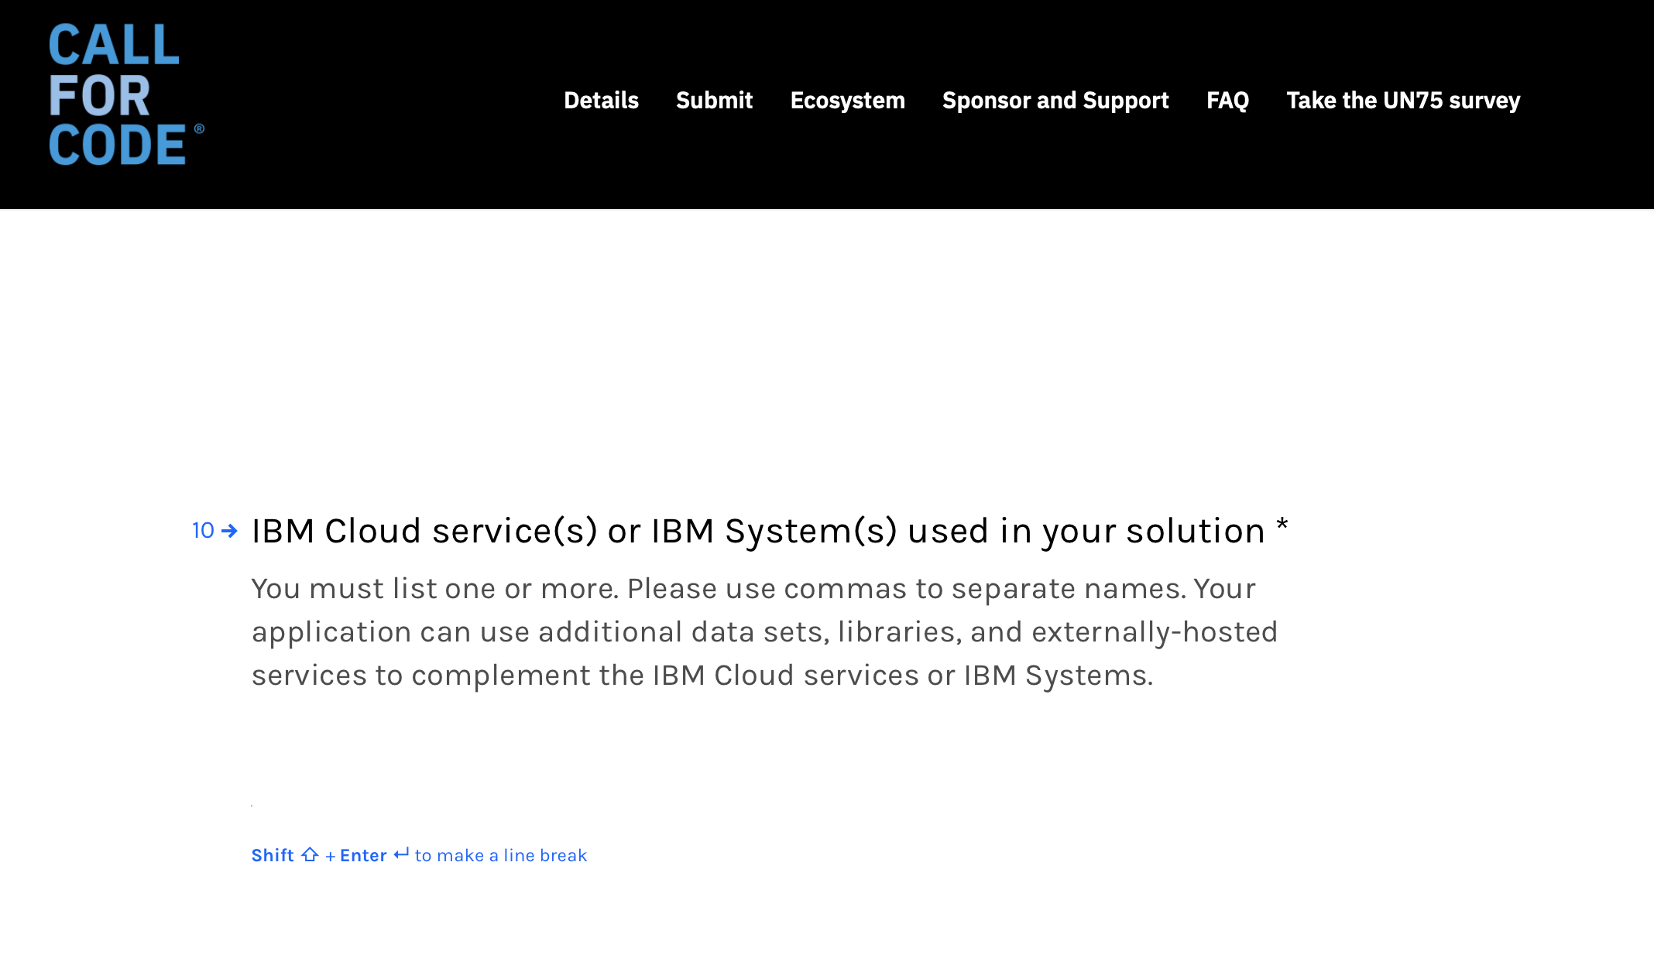

(r) After entering service or system names click on ***ok***

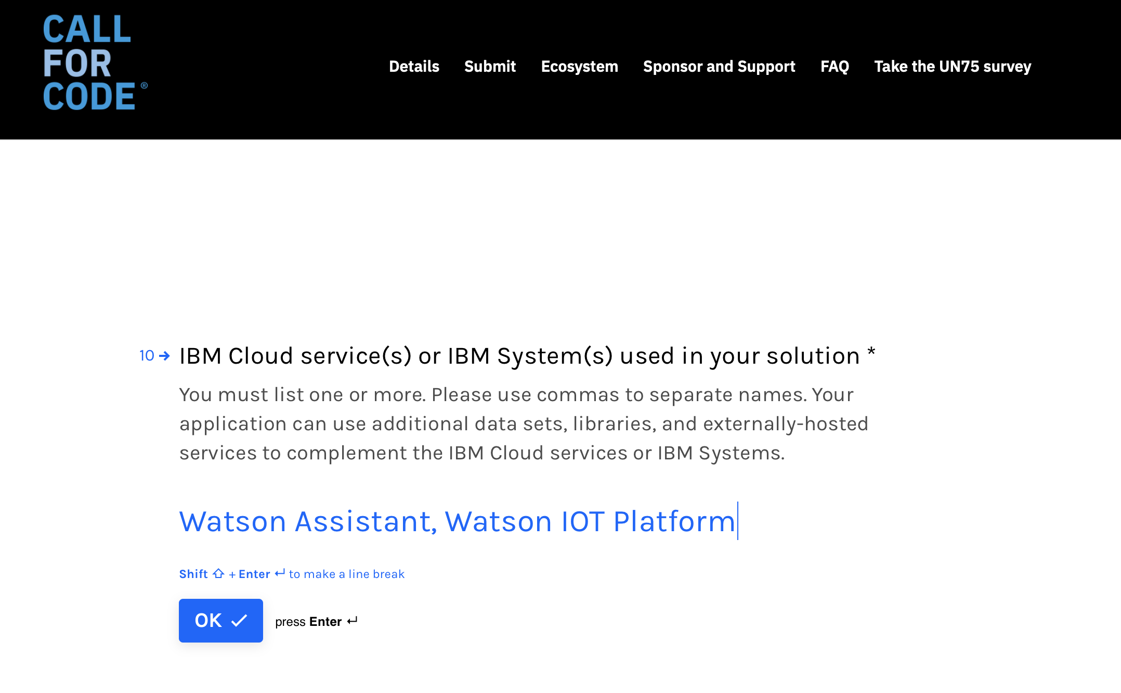

(s) Submit the necessary documents

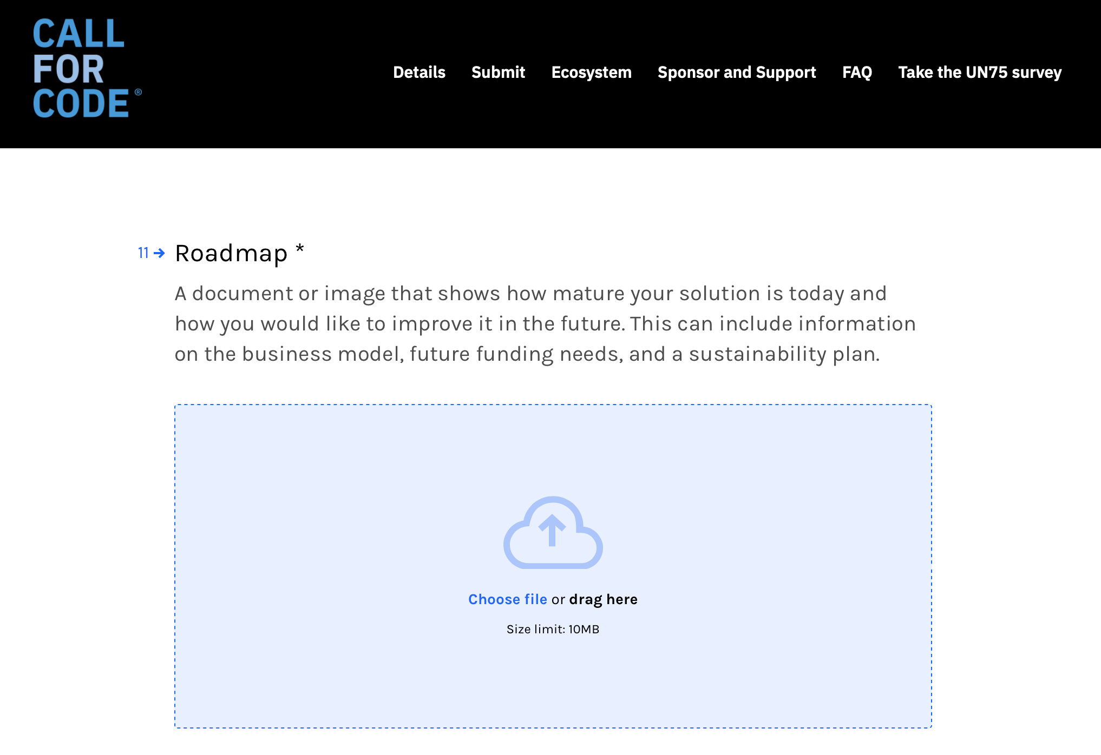

(t) Once after uploading the necessary documents or images click on ***ok***

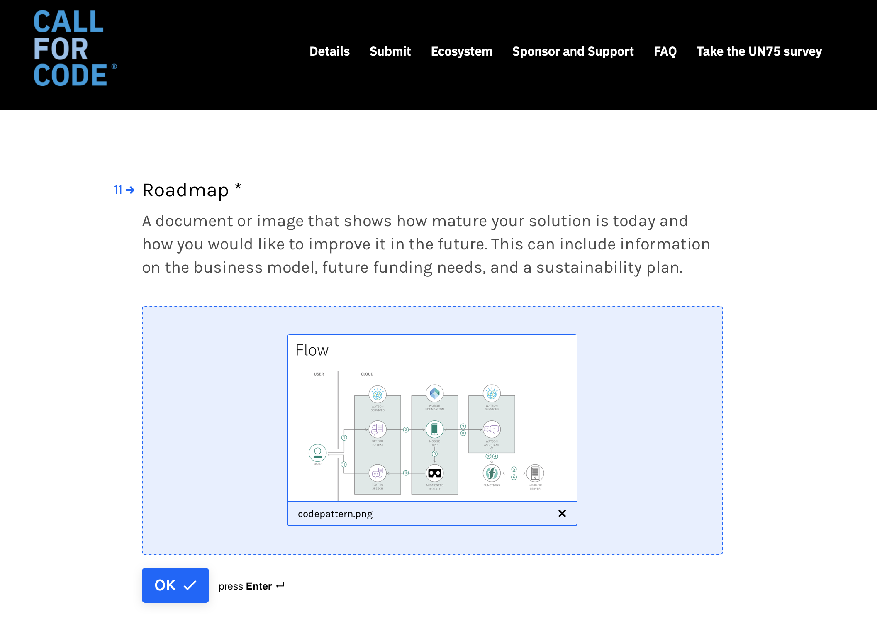

(u) Give your full as leader

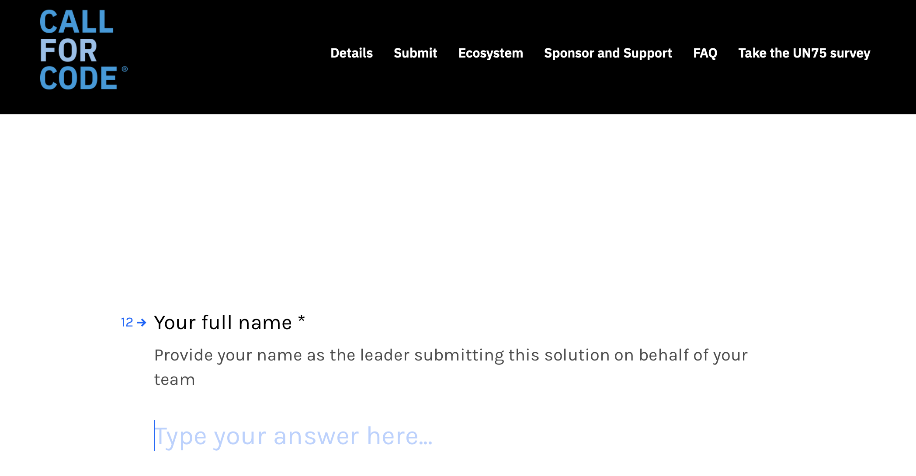

(v) Then click on ***ok***

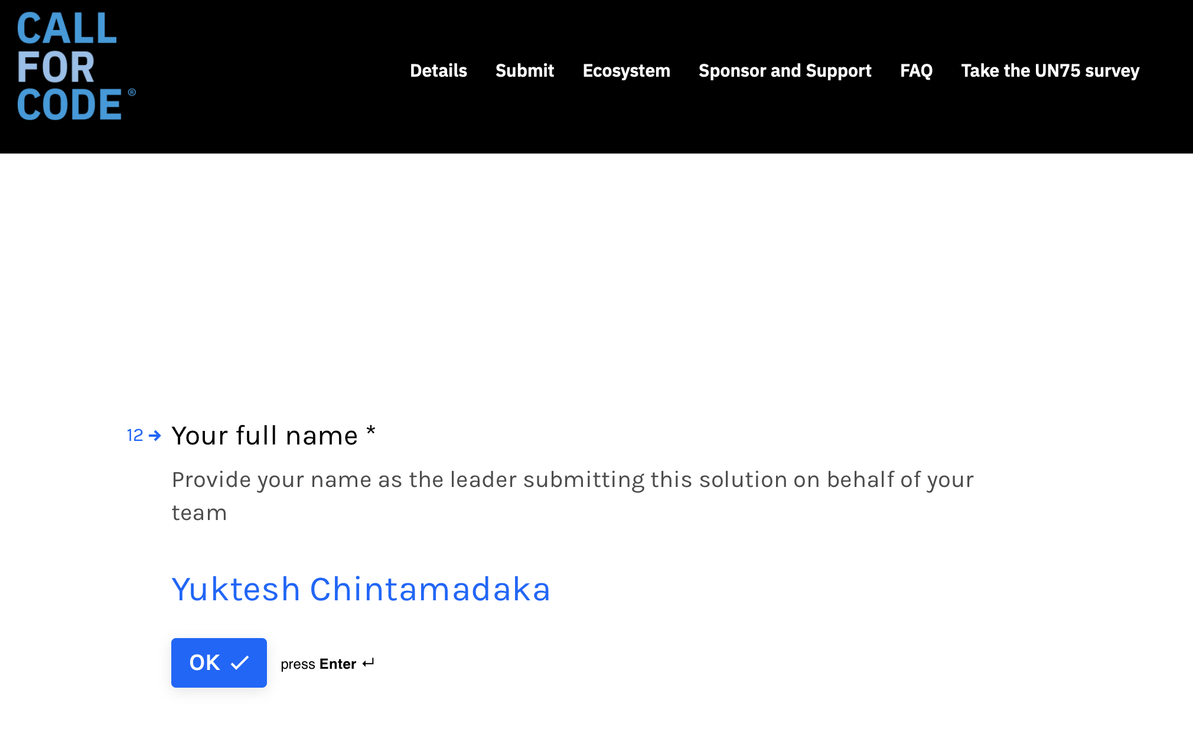

(w) Provide your email address

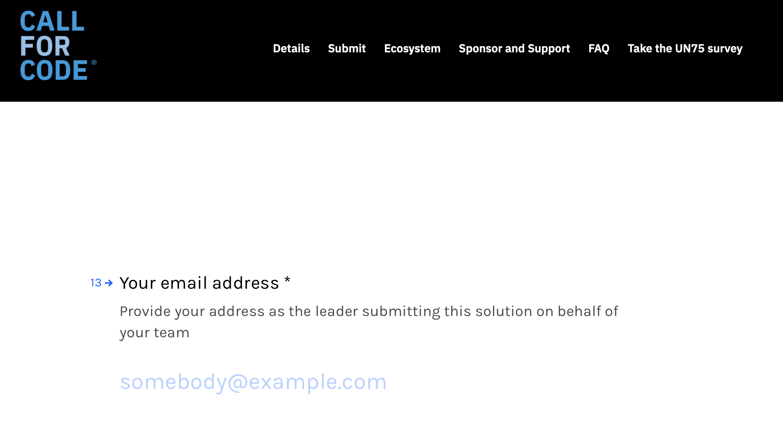

(x) and click on ***ok***

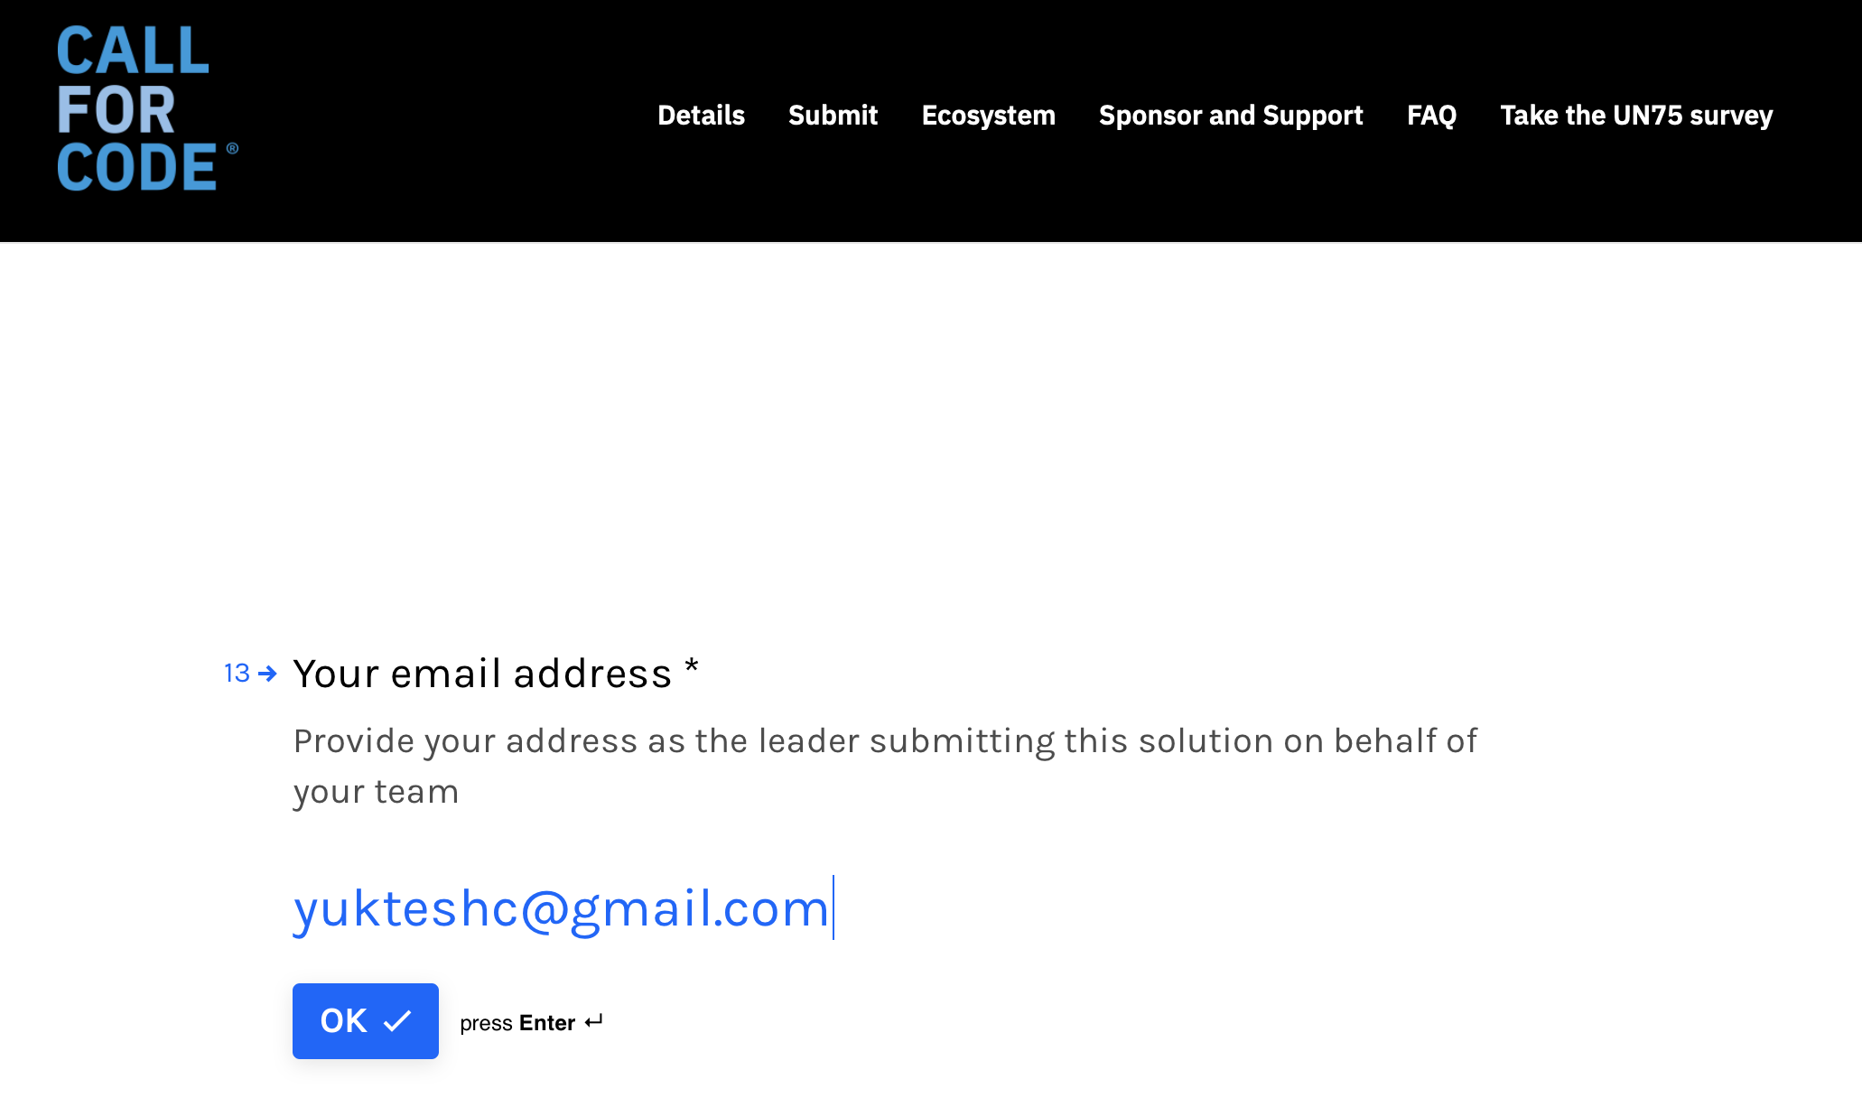

(y) Enter your country name

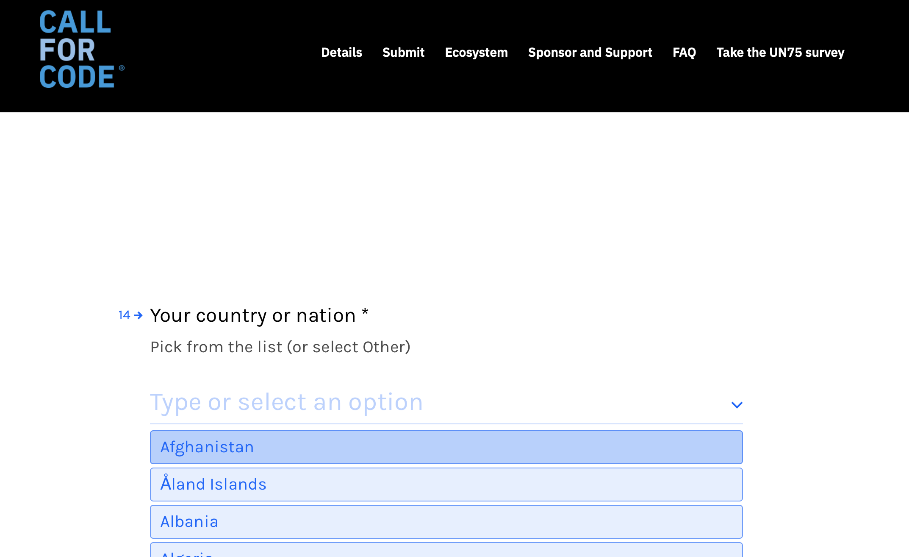

(z) select India and click on ***ok***

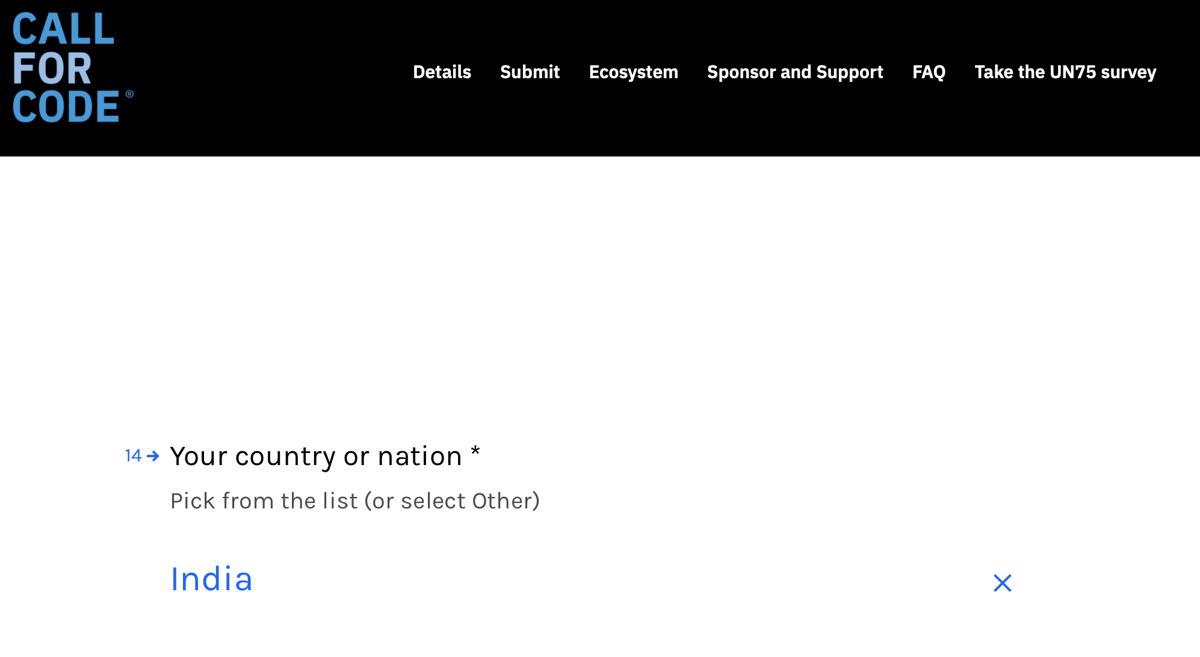

(a1) Give your college name or company name

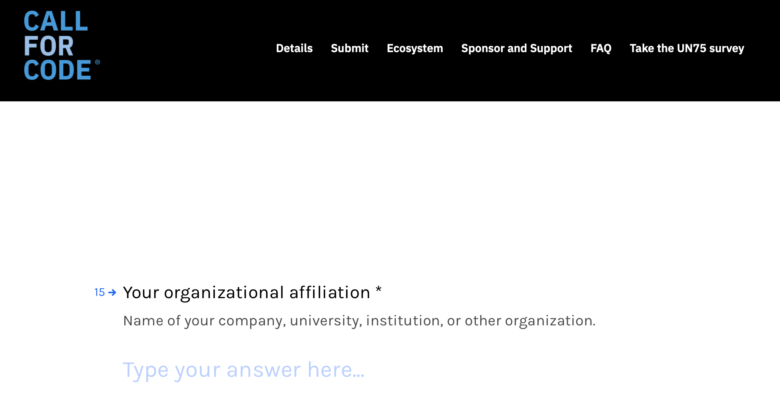

(b1) Then click on ***ok***

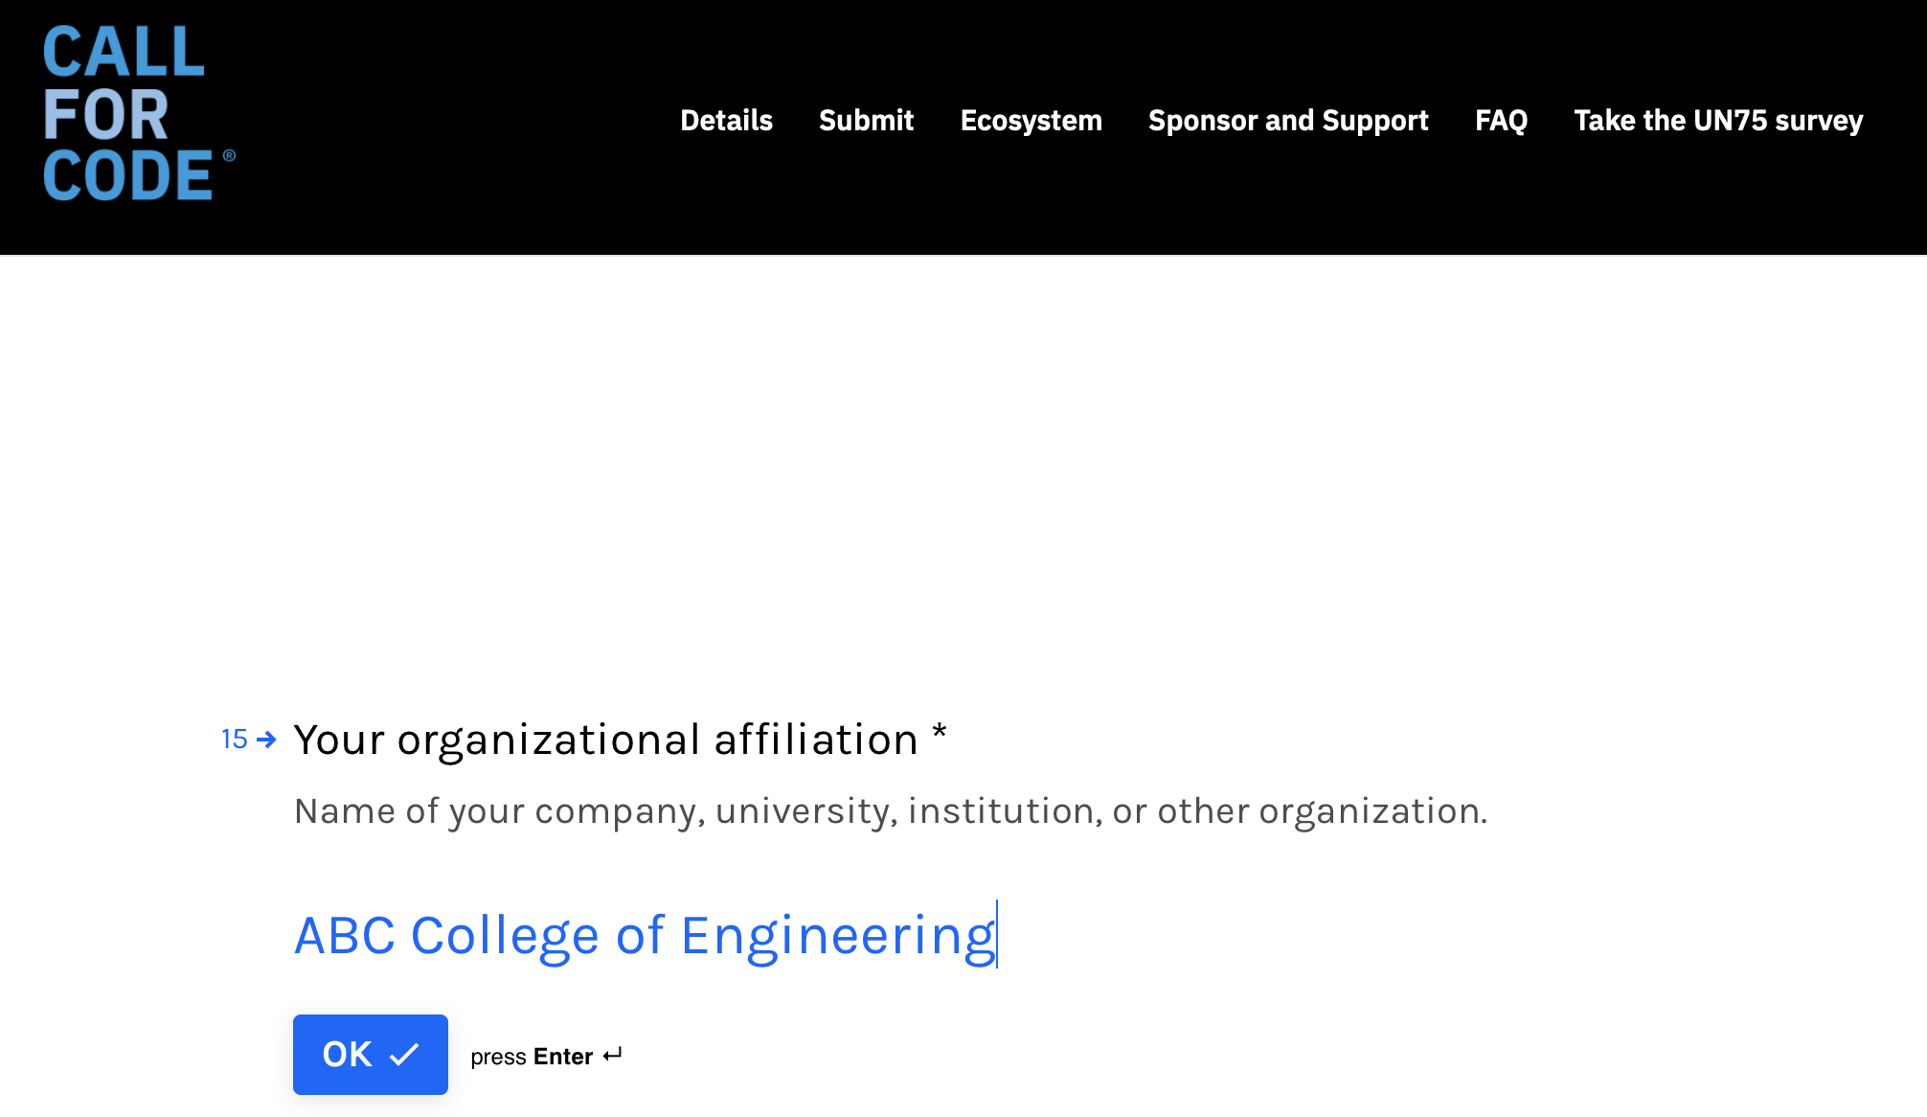

(c1) Enter Teammate 2 email address

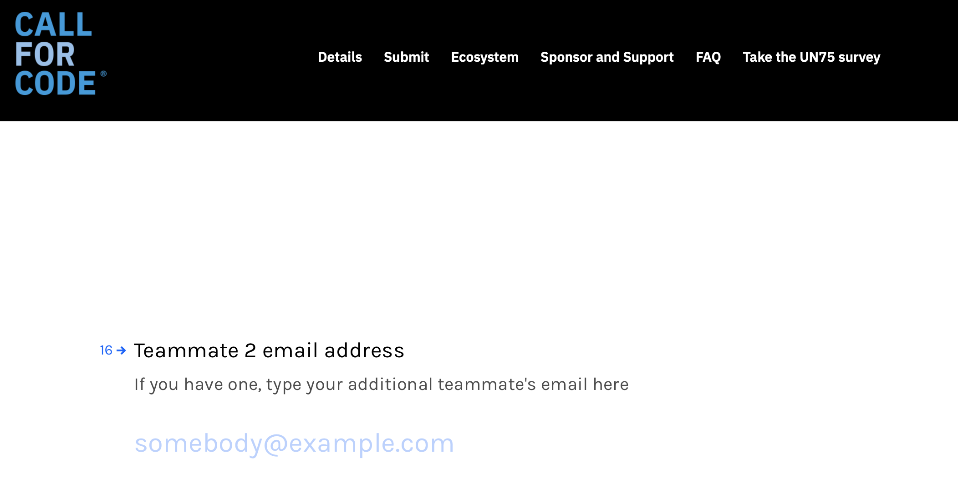

(d1) Then click on ***ok***

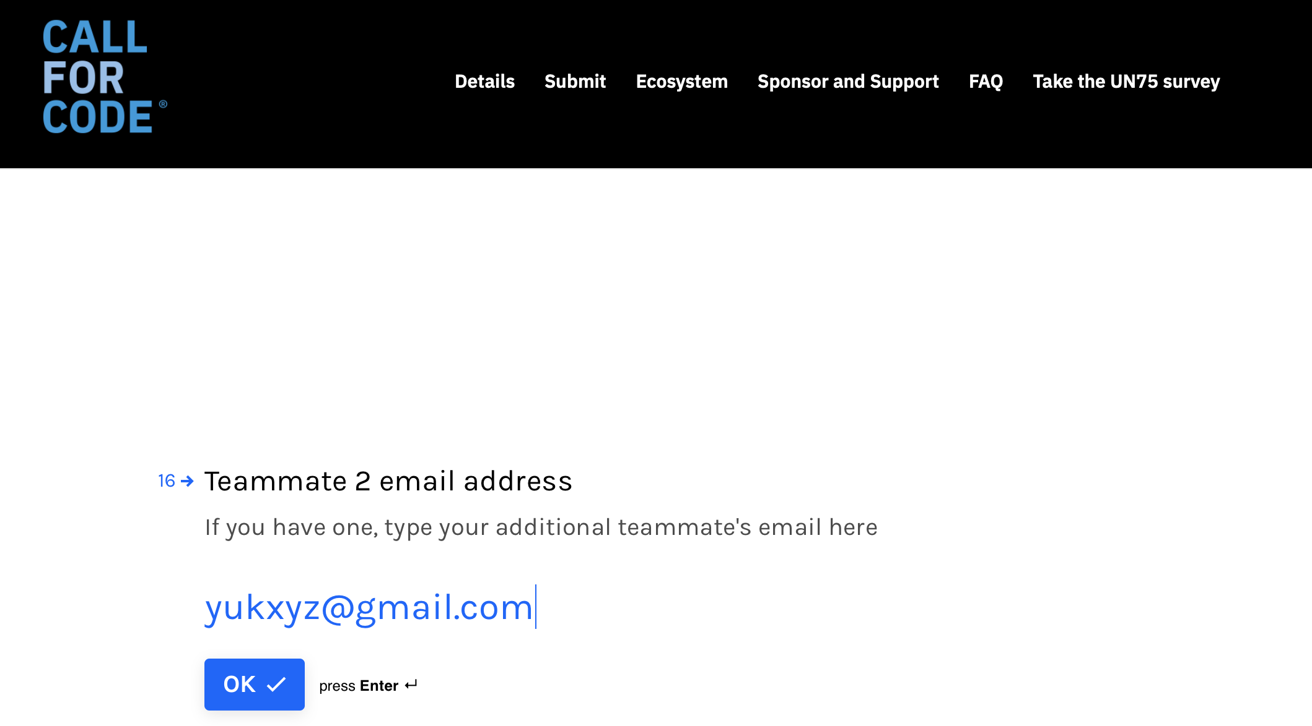

(e1) Enter Teammate 2 email address

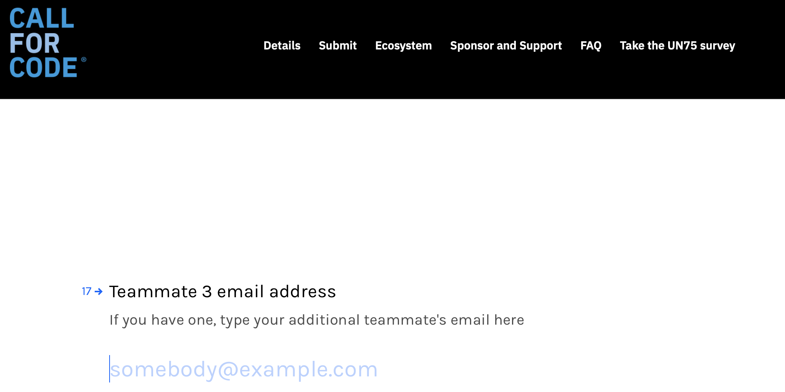

(f1) Then click on ***ok***

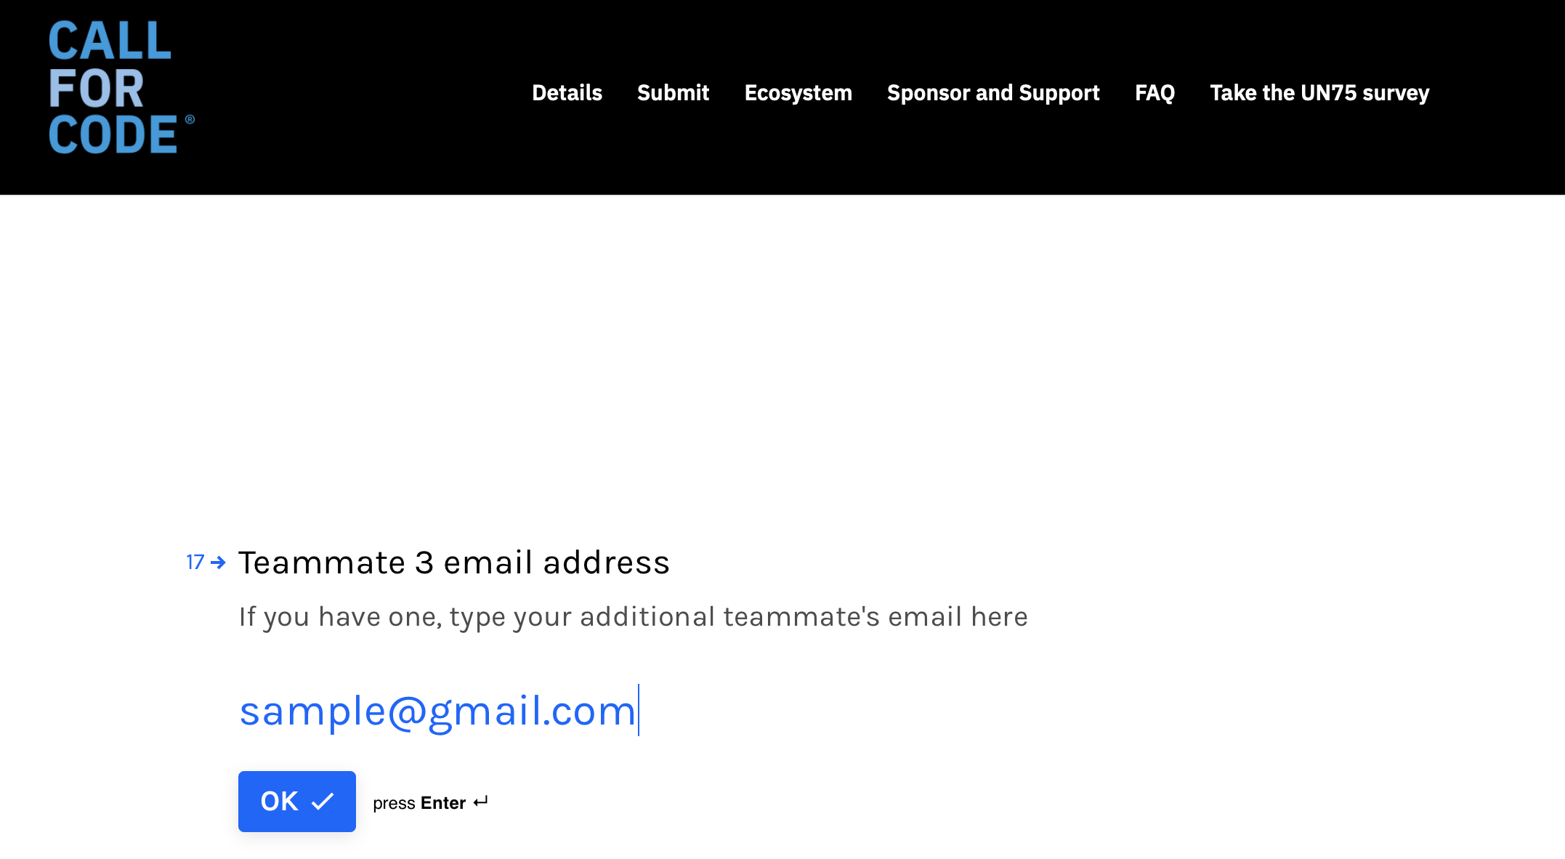

(g1) Enter Teammate 4 email id

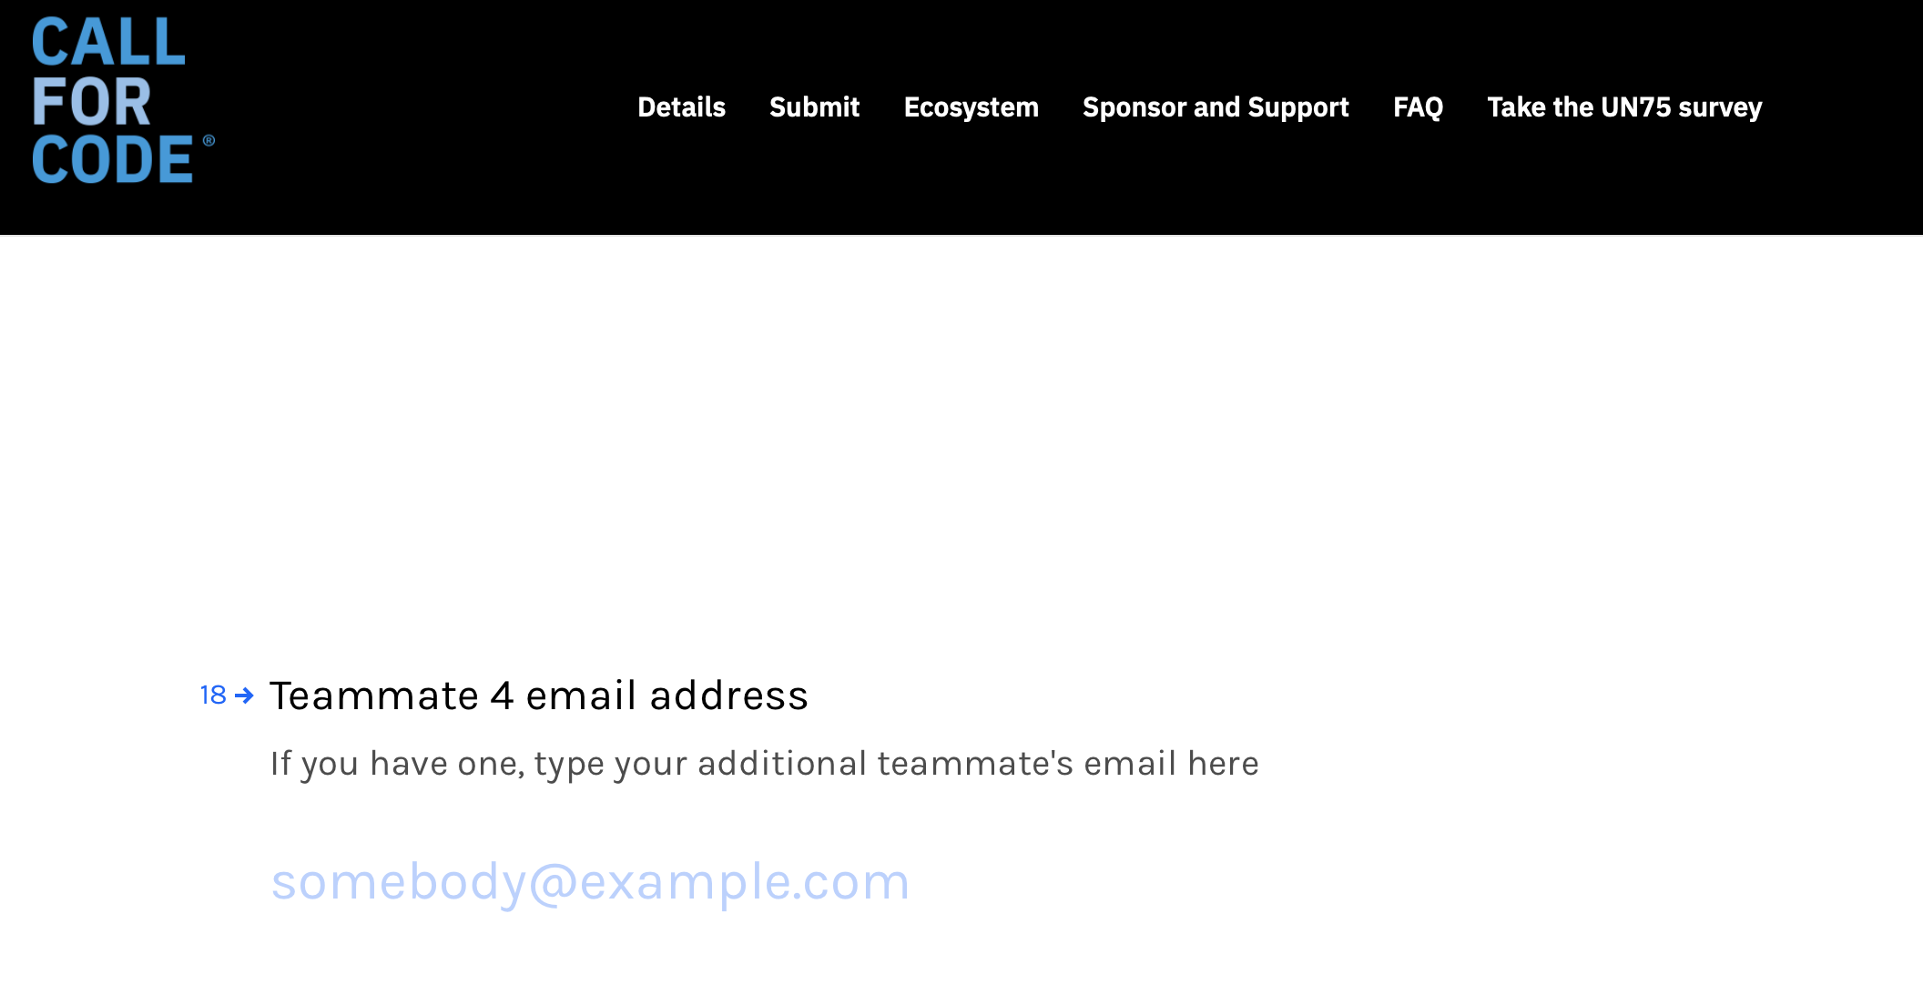

(h1) Then click on ***ok***

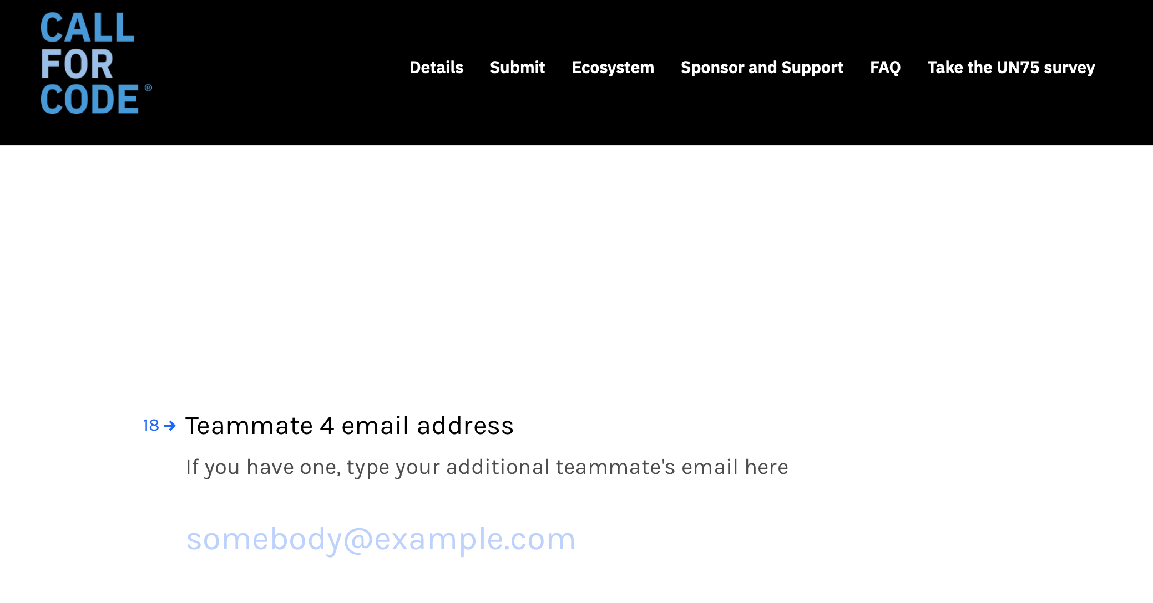

(i1) Enter Teammate 5 email id

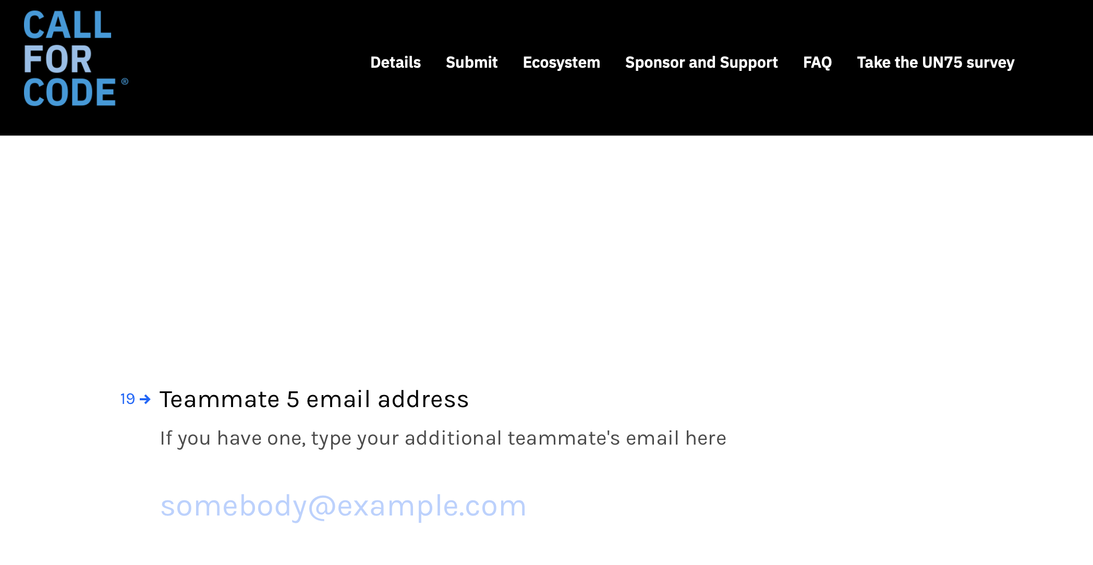

(j1) Then click on submit

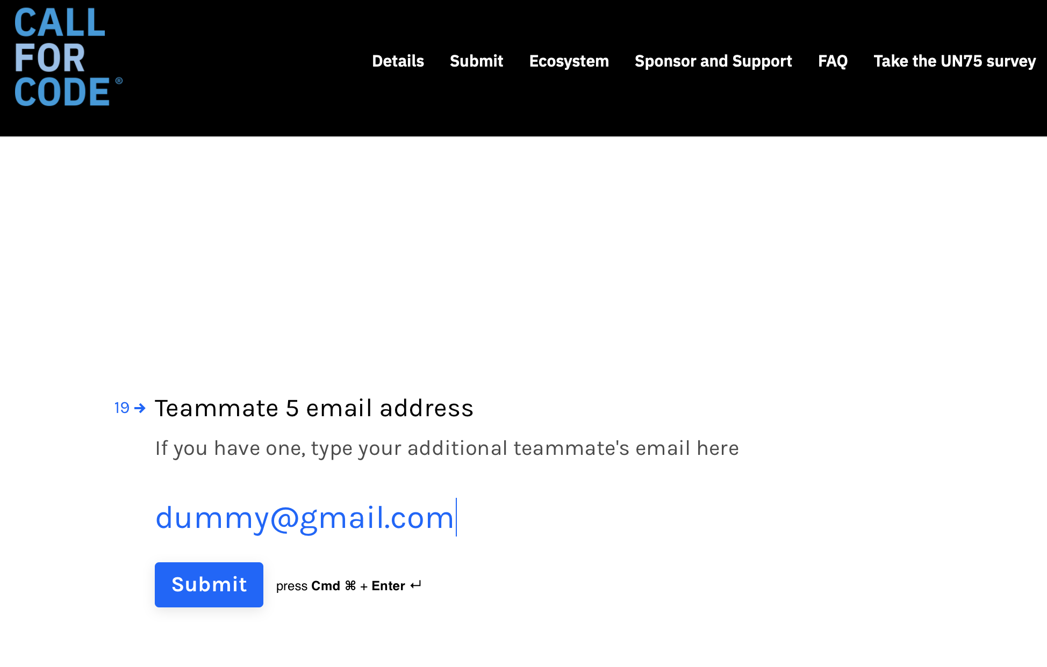

(k1) Here is the final message

